DiSC Group Culture Card Game

This game is meant to be played by groups who already have a basic knowledge of DiSC. It’s meant to be played after participants have received their DiSC profiles.

There are 20 green ‘Culture rewards’ and 20 yellow ‘Culture criticizes’ cards in the deck. Ask each group to choose and decide on 5 green cards which defines their group’s culture best, meaning which behaviours their culture rewards the most. (Option: group members need to give real examples from last year when these rewards were used). Next activity is to do similar with yellow cards - select 5 cards that define their group’s culture the best, meaning which behaviours their culture criticizes the most. (Option with behavioural examples).

When the abovementioned is done group will discuss about their team’s culture based on the 10 total words chosen and tries to put them under the right DiSC style. This enables group to connect their group culture to DiSC dimensions. Here you can hand out their group’s ‘Everything DiSC (or DiSC Classic) Group Culture Report’ and go more deep into this discussion with using the content of the profile.

You can print and produce the cards in a similar style:

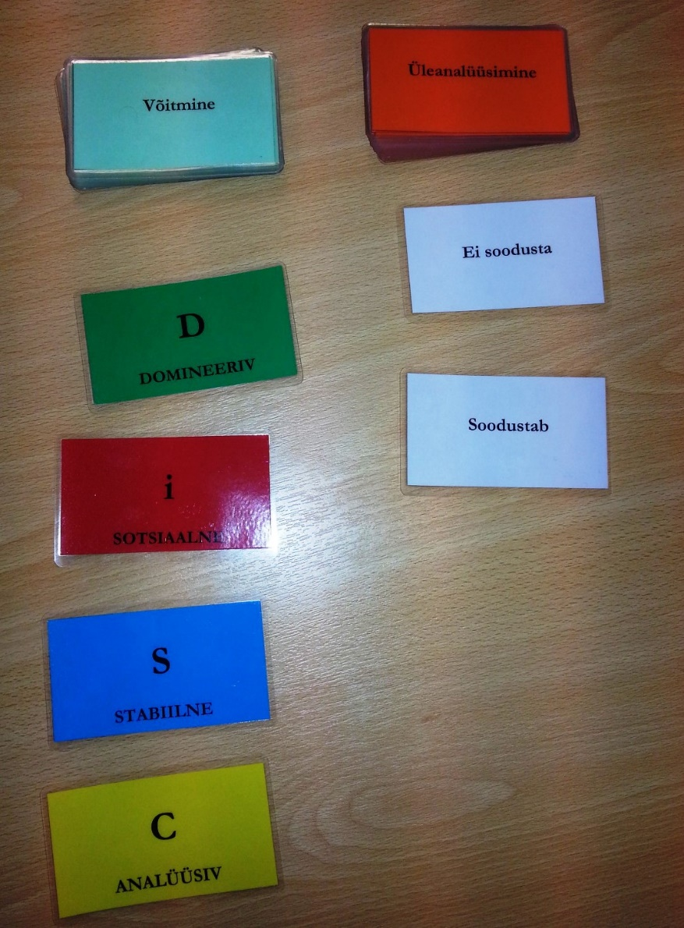

Independence | Decisiveness
Directness | Victory
Results | Creativity
Enthusiasm | Optimism
Collaboration | Passion
Oversensitivity | Hesitation
Overanalysis | Foot-dragging
Weakness | Rulemaking
Caution | Overanalysis
Introversion | Insensitivity
Rewards | Criticizes
D

DOMINANCE

i

INFLUENCE

S

STEADINESS

C

CONSCIENTIOUSNESS

Cooperation | Loyalty
Humility | Thoughtfulness
Team focus | Accuracy
Completeness | Attention to detail
On-time performance | Dependability
Aggressiveness | Pushiness
Disruptiveness | Nonconformity
Sudden change | Mistakes
Illogical behavior | Lateness
Spotty research | Exaggerated enthusiasm

