DiSC Group Culture Card Game

This game is meant to be played by groups who already have a basic knowledge of DiSC. It’s best to be played after participants have received their DiSC profiles.

The game goes together with the DiSC Group Culture report and adds value when dealing with the topic of team culture in training.

There are 20 green ‘Culture rewards’ and 20 yellow ‘Culture criticizes’ cards in the deck. Ask each group to choose and decide on 5 green cards which define their group’s culture best, meaning which behaviors their culture rewards the most. (Option: group members need to give real examples from last year when these rewards were used in their organization). The next activity is to do the same with the yellow cards - select 5 cards that define their group’s culture the best, meaning which behaviors their culture criticizes the most. (Option with real behavioral examples).

As a next step, the group will discuss their team’s culture based on the 10 words chosen and tries to put the words under the correct DiSC style. This enables the group to connect their group culture to DiSC dimensions. Here you can hand out their group’s Everything DiSC (or DiSC Classic) Group Culture Report and go more deeply into this discussion using the content of the profile.

You can print and produce the cards in a similar style:

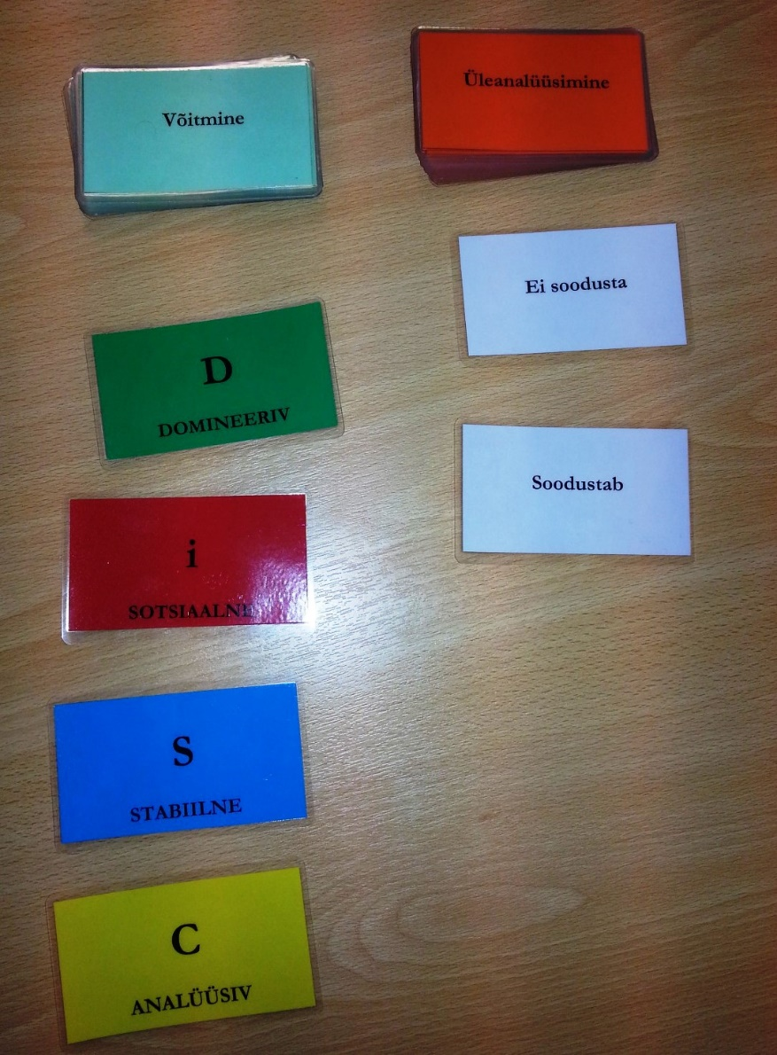

Cards (1 pack):

Independence | Decisiveness
Directness | Victory
Results | Creativity
Enthusiasm | Optimism
Collaboration | Passion
Oversensitivity | Hesitation
Overanalysis | Foot-dragging
Weakness | Rulemaking
Caution | Overanalysis
Introversion | Insensitivity
Rewards | Criticizes
D

DOMINANCE

i

INFLUENCE

S

STEADINESS

C

CONSCIENTIOUSNESS

Cooperation | Loyalty
Humility | Thoughtfulness
Team focus | Accuracy
Completeness | Attention to detail
On-time performance | Dependability
Aggressiveness | Pushiness
Disruptiveness | Nonconformity
Sudden change | Mistakes
Illogical behavior | Lateness
Spotty research | Exaggerated enthusiasm

